Setting up Garmin Connect
These instructions have been written to help you to get logged in to Garmin Connect on your phone, tablet or laptop.
You will have received details of the account we have made for you to login into on XXXXXX sheet. Please have these ready. By allocating a pre-made account to you, your data cannot be identified as being related to you other than by replacing your name and identifiable details with codes. Only via the secure databases used for STAMINA can these codes be used to identify data as relating to you.

Android phones and tablets
Ensure your phone or tablet is connected to the internet.

Step 1. Download and open the app.
- Open the Google Play Store
- Search for Garmin Connect
- Select the app that matches these pictures
- Tap Install and wait for the app to download and install
- Tap Open
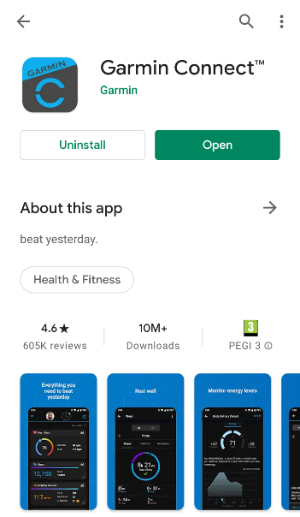
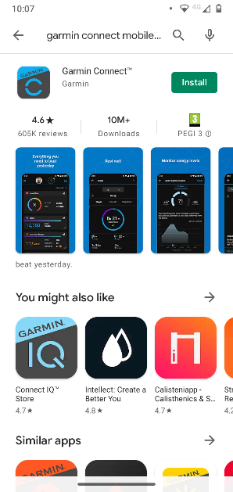
Step 2. Signing into your designated Garmin Connect account
- The first screen you will see will look like this. Tap the “Sign In” button.
- On the next screen, tap both the “I have a read and agree to the EULA” and the “I am 16 years or older option” so that ticks appear next to them. Tap “Next” to continue. If you wish to read the “End User License Agreement” click that text and you will be taken to another page – tap the back arrow or use the back function on your phone to return to the previous screen.
- Type in the username and password provided to you on XXXXXX sheet and tap “Next”.
- Next you will receive a prompt on your screen to allow your Garmin watch to stay connected to this app via your phone. Please click OK (can’t automate upload otherwise)

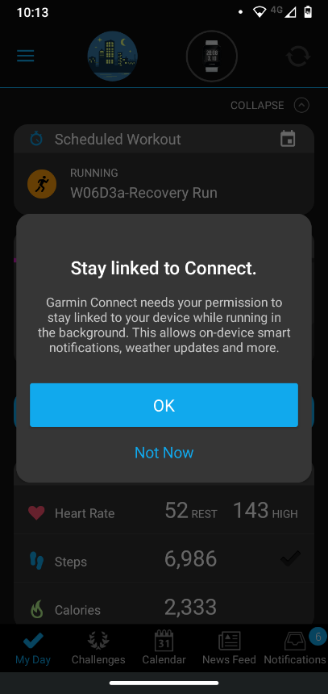
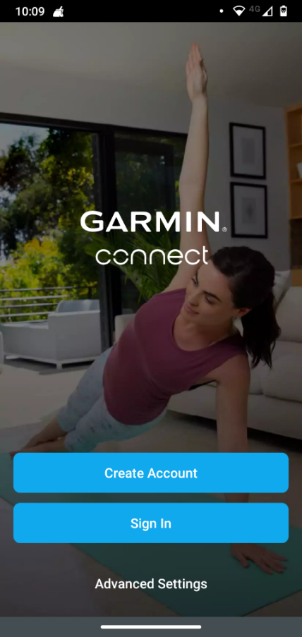
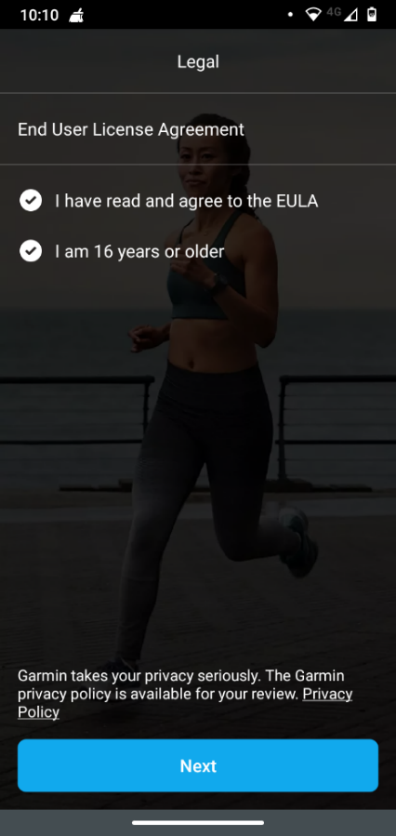

Step 3. Connecting to your device
- First make sure your Garmin watch is on (i.e. the battery has charge and the screen is on).
- Open the Garmin Connect app if you haven’t already.
- Tap the three horizontal lines in the top left of the screen to open the menu.
- Tap the “Garmin Devices” option
- On the next screen tap the “Add device” button
- You be prompted to allow the app to access the Garmin watches’ location. Choose one of the top two options.
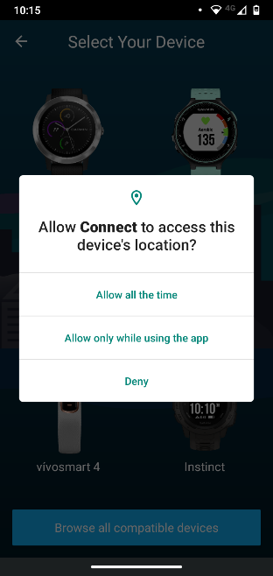
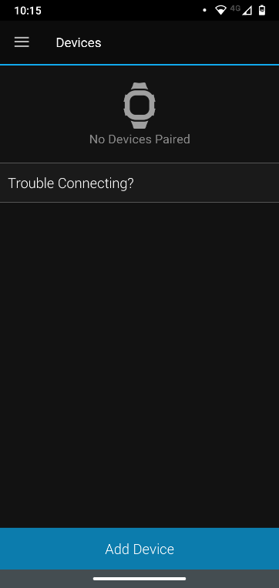
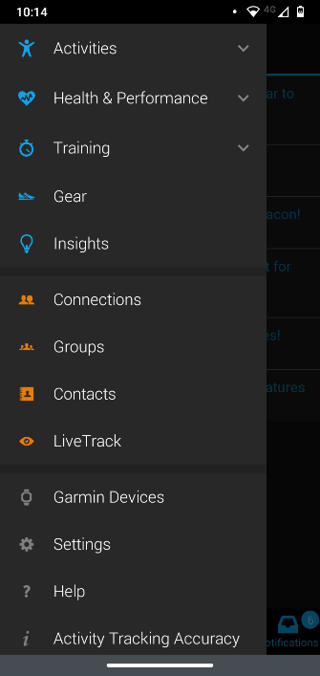

Step 3 continued
- Select your device by tapping its icon. The device you have been provided is the Forerunner 35.
- Your phone/tablet will now look for your Forerunner 35 watch. When it finds it, select the Connect it button.
- Next you will be prompted to type in a pin number. This 6-digit PIN can be found on the Forerunner watch screen. Tap the input box, type in the PIN and tap OK.
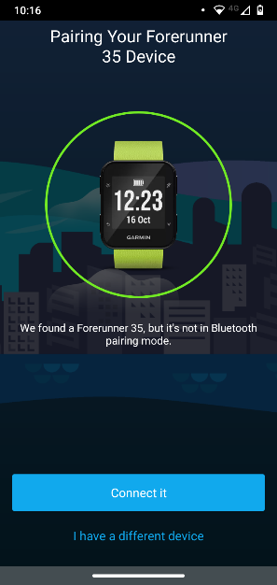
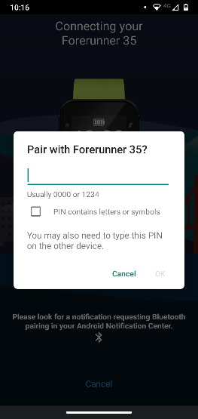
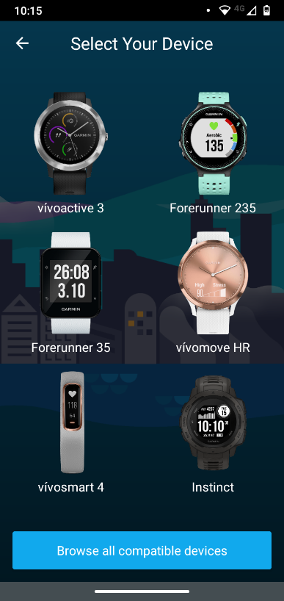
Step 4 – preferences and syncing
- Next you will be asked when you typically sleep. We will not use this information or track your sleep for STAMINA.
- Set times of your choosing (accurate or inaccurate). You can then decide whether to receive notifications during that time. In later steps we will describe how to turn all notifications off.
- Tap Next. Your Forerunner watch will now synchronize itself with Garmin Connect. Wait until this process is complete.
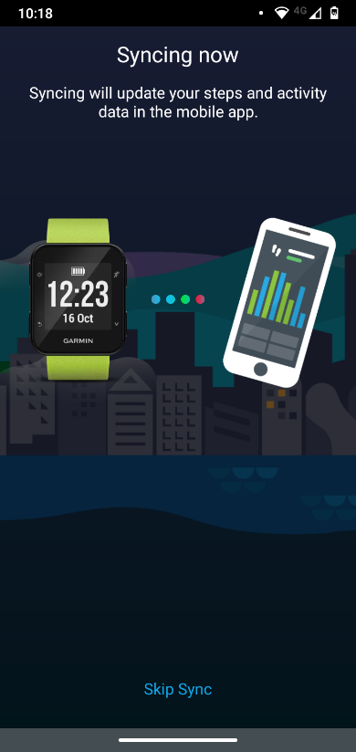
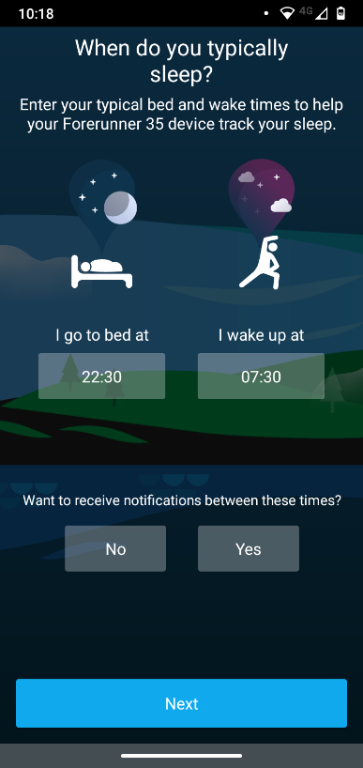
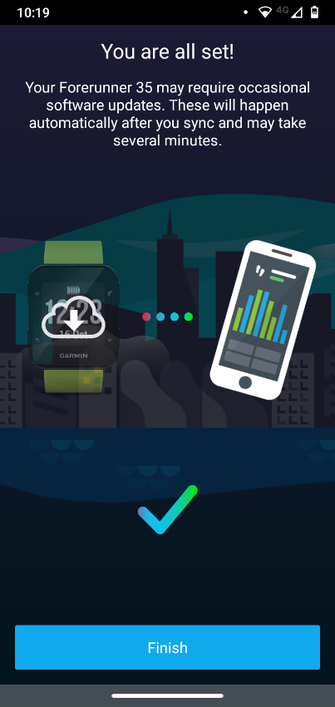
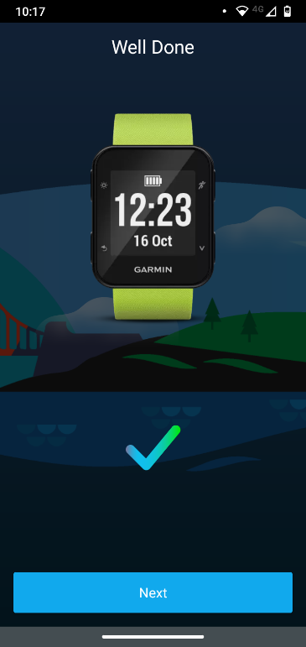
Step 5 – routine syncing
- This is an example of a typical home screen on the Garmin Connect.
- The primary use of this app for the STAMINA programme is for you to upload your heart rate data regularly.
- To do this tap the blue circular arrows option in the top right of the screen. You will see the arrows turn white and the icon next to them will move – with the white outline of the circle showing how much of the sync has completed. The sync will finish once the whole outer circle is white.
- The sync is complete. You may close the app.
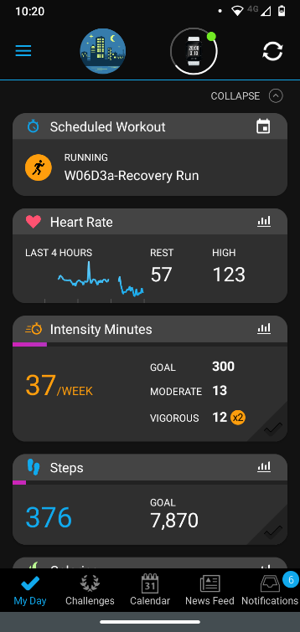
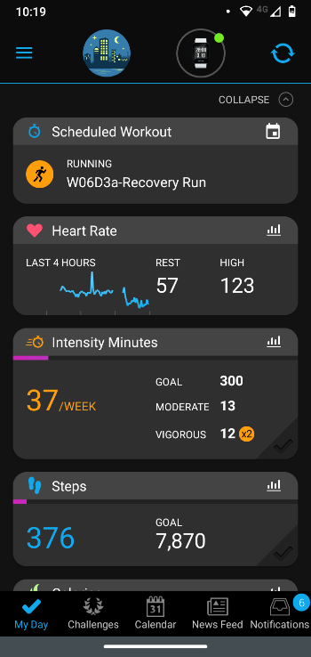
Step 6 – preventing unwanted notifications
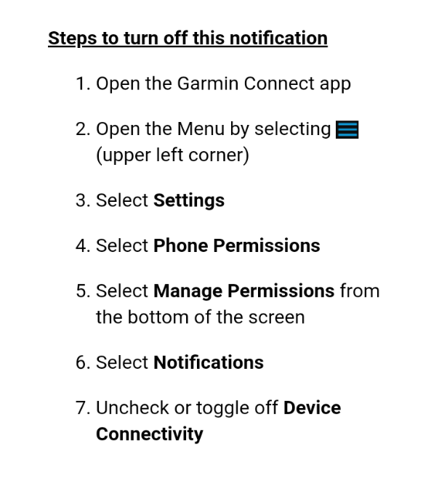
- Technology can cause unwanted notification sometimes. Sometimes Garmin Connect will send you a notification because it is on in the background. To get rid of this notification follow these steps.
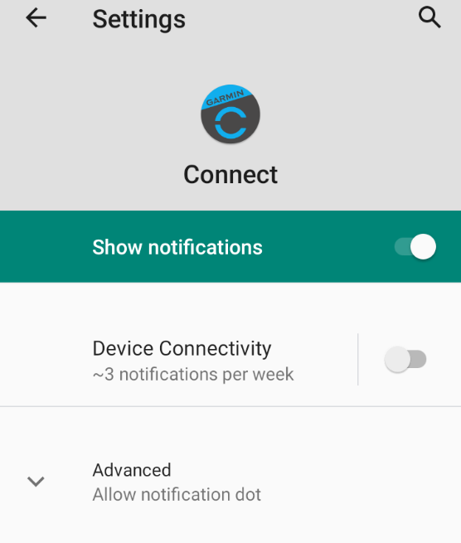
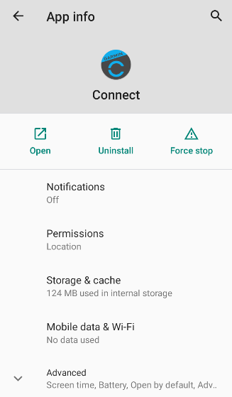

Apple phones and tablets

PC

